SELECTING AND ADAPTING LEARNING TECHNOLOGIES TO
IMPROVE ENGINEERING EDUCATION

Flora McMartin¹ and Brandon Muramatsu²

¹ Evaluation Director, NEEDS, University of California at Berkeley, Berkeley, CA 94720-1750, mcmartin@needs.org.
² Project Director, NEEDS, University of California at Berkeley, Berkeley, CA 94720-1750, mura@needs.org.

Abstract⎯As we enter the 21st century the pace of development of web-based and web-accessible collections of learning materials for science, mathematics, engineering and technology continues to accelerate. However, when confronted with the wide array of potential resources it is often left up to the individual faculty member to decide how to select and use these materials. One of the primary goals of NEEDS, a digital library for engineering education, is to encourage faculty use and re-use of these materials.

This paper will address mechanisms and methodologies to help faculty better locate, select and evaluate digital learning resources. We will discuss different types of selection criteria and methods for evaluating digital learning materials and technologies. We will build upon our development of the Premier Award for Excellence in Engineering Education and will discuss a taxonomy describing the different uses of technology to promote specific learning goals and pedagogies.

Index terms⎯ digital library, computer based education, technology and learning

Introduction

The advent of the World Wide Web and the increasing integration of computer-enhanced learning materials into teaching have supported the rapid increase in the development of digital materials to support teaching and learning in science, mathematics, engineering and technology (SMET). Instructional and learning technologies in the 21st century have created opportunities for engineering faculty to teach in new and exciting ways. Faculty can personalize instruction for multiple learning styles, diversity of backgrounds and varying career aspirations of 21st century students; incorporate pedagogies (e.g., active learning or collaborative learning) that are based in cognitive science and research on learning; and incorporate visualizations and simulations into classes and labs to give students personal experience with engineering practice or the underlying science (e.g., design a disk drive in a virtual studio [] simulate “necking” in a polymer specimen [] or experiment with the structural design of bridges []). Faculty can build learning communities that cross time and space; employ Just-in-Time Teaching techniques [] or can connect students to research involving real time databases.
The benefits to teaching and learning are potentially huge; the reality is that engineering faculty, like others, are daunted by the prospect of effectively using digital resources to improve student learning. Faculty face many barriers when attempting to integrate technology into their courses: finding high quality learning materials and the lack of time and money to develop them or integrate them in their teaching [, , , , , , ]. In addition, a significant barrier to faculty adaptation and use is the lack of institutional and professional rewards for doing so [, , ].
Because of these barriers (and more), the promise of instructional and learning technologies may go unfulfilled. This paper will discuss some of the mechanisms and methodologies NEEDS⎯The National Engineering Education Delivery System, digital library for engineering education, recommends to help faculty better locate, select and evaluate digital learning resources. We will discuss different types of selection criteria and methods for evaluating materials found in NEEDS and other educational digital libraries. We will build upon our development of the Premier Award for Excellence in Engineering Education, work underway to develop peer review systems for online learning materials and workshops we have given on the selection and use of learning materials. In addition, we will present a taxonomy describing the different uses of learning technology to promote specific learning goals and pedagogies.

Frameworks for Designing Learning Environments for a Course

When considering the factors in designing a learning environment for a course, engineering faculty members are confronted by the wide array of teaching and learning tools, multiple philosophies of teaching and contradictory views of student learning. Adding technology and computer-enhanced teaching and learning tools to this mix confounds the issues even more. In the following section, we will discuss two sets of guiding frameworks useful in course design.
Research on faculty adaptation of innovation in higher education indicates that the process is most successful when faculty have the opportunity to work with and learn from respected colleagues who have tried the strategies and developed materials about which potential adapters are already curious, and that successful learning environments are those in which faculty have aligned learning tools and activities with their goals for promoting learning [, , , , , ]. This requires that a faculty member become a “Jack, or Jill, of All Trades,” solving educational problems by combining different learning strategies (e.g., collaborative learning or student-based inquiry) with instructional technology and relevant assessment techniques []. In this view, learning technologies are one of many tools that faculty can use to help promote specific learning goals. Figure 1 illustrates one simplified process a faculty member might engage in when planning a course and designing a learning environment and set of learning processes and activities to support it.

FIGURE 1
framework for evaluation & selecting Instructional

In the process outlined in Figure 1, the faculty member gives initial consideration to identifying course goals and student learning outcomes before deciding on the type of learning environment he or she wishes to encourage, the type of learning process that will best support student learning (e.g., individual versus collaborative) and the kinds of learning activities that will support help accomplish the learning outcomes. The selection of learning tools is guided not by the array of tools or processes available, but by the overall learning goals.
Since the primary purpose of this paper is to examine the selection of computer-enabled learning resources, we have found the following taxonomy for selecting technology based learning materials (see Figure 2) suggested by John Jungck and others [] to be particularly helpful. This taxonomy has three axes: nature of learning, type of collaboration and degree of learning centeredness. The Nature of Learning Task axis emphasizes transformation from “drill and practice” tutorials to open-ended problem-solving, experimentation with multiple approaches and to where student work is authentic research. This axis is helpful in the design of the learning task. The Collaboration axis emphasizes the transformation of classroom activities from individualistic competition to cooperative group work to collaborative learning and the social construction of knowledge. This axis and the design of the learning process have a strong overlap. Here, the instructor must examine the role of collaboration in learning and create processes that support the learning environment he or she wishes to establish. This part of the process is closely related to the over all effort in creating a learning environment described by the Learning Centeredness axis. This axis emphasizes teaching and learning that transforms from student as “receiver of knowledge” to a “constructor of knowledge.” On one end, we find behaviorist and passive (watch, read, apply, and regurgitate) forms of “instruction” where the computer is the holder of information and the evaluator rewards student’s responses. At the other end we find constructivist, learner-empowered strategies where students have high responsibility, freedom to explore, individual engagement, multiple modalities and take ownership of learning.
Establish Course Goals
Identify Student Learning Outcomes
Design Learning Environment
Design Learning Process
(e.g., individual or collaborative)
Design Learning Activities
(e.g., computer or other non-computer
Assess Student Learning

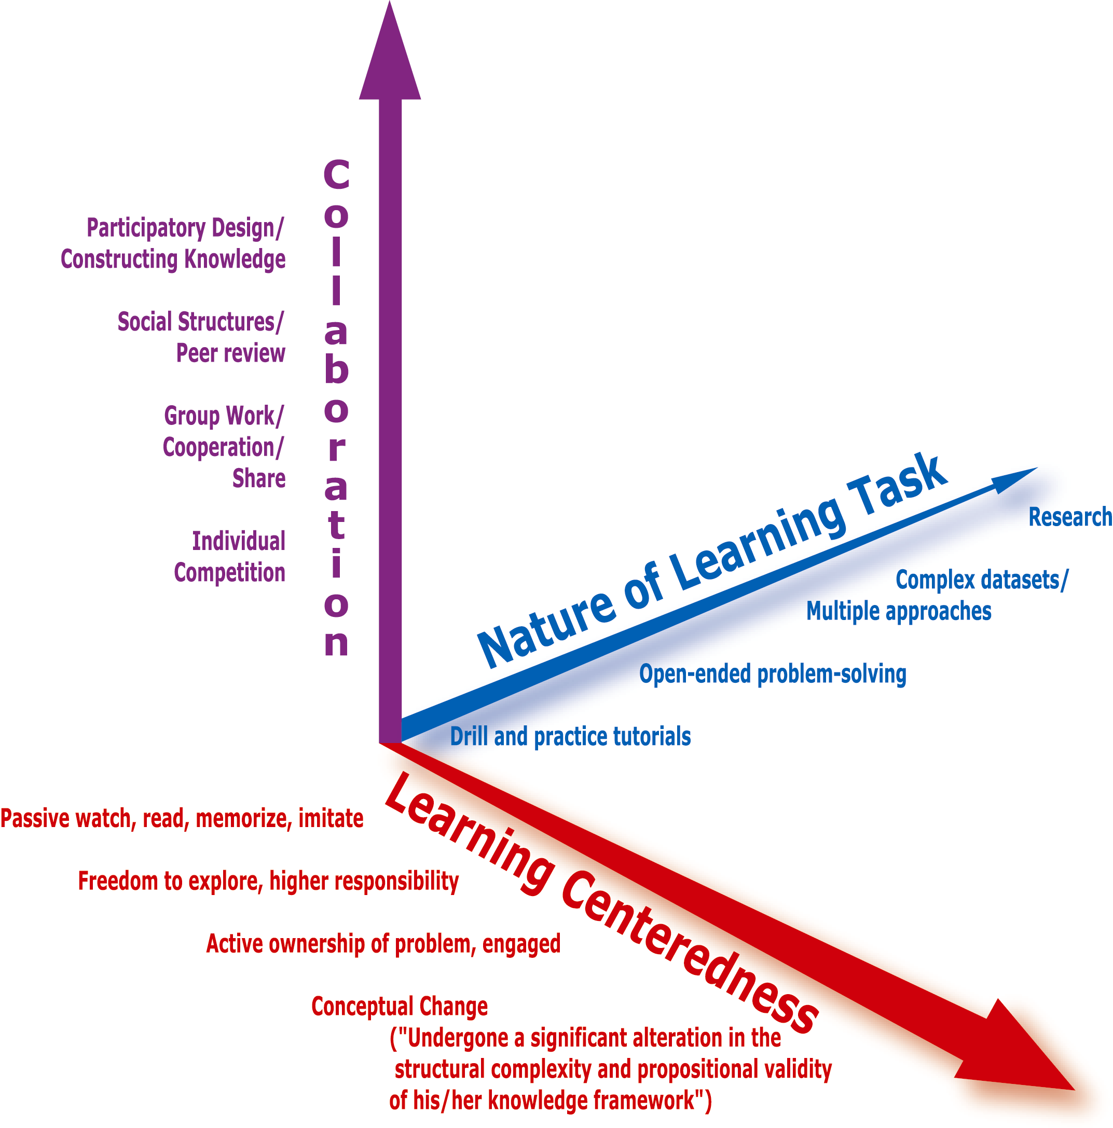

FIGURE 2
taxonomoy of selection criteria

To help accomplish the goals outlined in the taxonomy, we must also consider what constitutes good practices in higher education. A useful guide is Chickering’s [] Seven Principles, which are based on research on good teaching and learning in colleges and universities. These principles, outlined in Table 1, are also useful guides when considering teaching activities.

TABLE 1
seven principles of good practice in undergraduate education
- Encourages contact between students and faculty
- Develops reciprocity and cooperation among students
- Encourages active learning
- Gives prompt feedback
- Emphasizes time on task
- Communicates high expectations
- Respects diverse talents and ways of learning

The principles in combination with the learning technologies and tools available can have a powerful impact on learning. By designing learning activities with computer-enhanced learning materials, faculty can support the good teaching practices outlined in Table 1. For example, a case study or virtual learning environment can support a variety of student ways of learning by allowing students to explore and interact with the content through hands-on learning activities, conceptual discussions of the material or through simulations. Other tools may support experimentation with continuous feedback or through group work. Ultimately, computer-learning materials may be most effective because students can use them any time, anywhere—this flexibility can “extend” the classroom experience beyond the time and space boundaries that typically define a course.

Guidelines for Selecting Learning Technologies

Criteria for Evaluating Learning Technologies

In combination, the frameworks described above are critical underpinnings to the selection of instructional and learning technologies. They can help instructors clarify their teaching and learning goals and clarify for them how a particular tool may or may not support their goals. However, these frameworks are context free and are not bound by the constraints of cost, time and expertise. As we described earlier, these barriers can be significant hurdles for an instructor to overcome in using technology in teaching. Educational digital libraries such as NEEDS can help faculty overcome some of these barriers by making available high quality digital learning materials at low or no cost and can connect faculty to other instructors who are experienced in using these materials. Still, each individual faculty member must review these materials to decide which will best meet his or her needs and course goals. This can be a time consuming and almost overwhelming process given the wealth of choices in some areas.
NEEDS attempts to streamline the process of faculty review of materials for use by providing peer reviews of digital learning materials, user comments and identifying select courseware as Premier Awardees. Premier Award winning materials are reliable, tested courseware that add value to the learning environment. These materials take advantage of the digital medium to enhance the learning experience beyond the traditional textbook and chalkboard models. Faculty, instructional design experts, cognitive scientists and students defined the criteria used to select these materials. Over the last four years, they have been found to be reliable markers of excellence and are a useful basis for engineering faculty to use in selecting courseware [].
The Premier Award criteria focus on three aspects of computer-enhanced learning materials: the instructional design, software design and content []. Within each area specific criteria are described, as outlined in Table 2.

TABLE 2
premier award selection criteria
part I. Instructional Design
A. Interactivity: The learner is actively involved in the learning process — the interaction enhances learning.
B. Cognition/Conceptual Change: Learning appears to be significant and long lasting, and strong and useful cognitive models can be built.
C. Content: The content is well chosen and structured.
D. Multimedia use: Multimedia is used effectively and promotes the learning objectives and goals.
E. Instructional Use/Adaptability: The software can be used in a variety of settings.
PART II: Software Design
A. Engagement: The software holds the interest of a diversity of learners.
B. Learner Interface and Navigation: The software is easy to use.
C. Technical Reliability: The software is free from technical problems.
PART III: Engineering Content
A. Accuracy of Content: The content is accurate.
B. Organization of Content: The software is structured consistent with typical engineering instruction.
C. Consistency with Learning Objectives: The content matches the stated learning objectives and goals.

The following example shows how these “top level” criteria are expanded upon and defined. In Instructional Design interactivity is demonstrated when the following occurs:
- The software responds appropriately to learner actions.
- Communication is two-way.
- Learners control their own pace and are informed of their progress so they can make informed decisions about how to proceed. Learners decide: what they want to learn; in what order; and how deeply they want to concentrate on specific topics.
- Choices that learners make are meaningful and not “just for the sake of making choices”.
The instructional design is further enhanced when:
- Learners are presented with relevant problems to solve; exemplary solutions are included.
- The learner can select the type of media that she wants to use (e.g., audio, transcript, etc.).
- There are questions and challenges to help the learner monitor his or her progress.
- There is an analysis of learner input and useful, appropriate feedback.
- The system adapts its delivery style or content based on learner actions.
This example of how effectively a particular learning technology meets the Premier Award criteria, shows how the criteria integrates the aspects of teaching and learning described by Chickering’s Seven Principles and the criteria outlined in Jungck’s taxonomy. In this example, students are active participants in the learning—“plug and chug” is not an option, there is two-way communication, they make choices that are meaningful, and they can control their pace of learning. To be judged exceptional, courseware must support higher levels of learning, be exemplified by problem solving, address different learning preferences and the feedback to the learner must be regular and systematic. These criteria then, are useful for faculty and instructors in evaluating courseware to meet their needs.

Guidelines for Selecting Learning Technologies

The realities of each faculty member’s campus and course must come into play when considering how to integrate learning technologies into a course. The research conducted by the National Institute for Science Education’s Institute on Learning Technologies [] identified how strongly the context for the learning situation can impact the success of a faculty member’s ability to integrate technology into their courses. The guidelines in Table 3 are a synthesis of these findings, research on faculty needs with regards to digital libraries [] and the frameworks previously described. The guidelines, in the form of questions, are designed to help instructors consider the philosophical and pedagogical aspects of using learning technologies as well as the practical matters involved in the use of these important learning materials.

Summary

Our goal in presenting the guidelines above, has been to illustrate many of the areas faculty should consider when selecting and evaluating learning technologies for their courses. Each alone is not sufficient, but together, the taxonomy, frameworks, and guidelines lay out a process that will lead to successful integration of learning technologies to improve engineering education.
TABLE 3
guidelines for selecting learning technologies
Good Practices in Undergraduate Education
- Does this courseware encourage:
- student-faculty contact?
- cooperation among students?
- active learning?
- Does this courseware give prompt feedback or provide opportunities for students to get it from instructors or peers?
- Does this courseware emphasize time on task?
- Does this courseware help me communicate high expectations of my students?
- Does this courseware address diverse learning styles?

Goals of Higher Education
- Does this courseware support my teaching goals regarding
- higher order thinking skills
- basic academic and communication skills
- discipline-specific knowledge and skills
- liberal arts and academic values
- work and career preparation
- personal development

Practical Matters
- Can students easily grasp how to use this courseware?
- Do students have access to the necessary support for using this courseware? (Internet access, correct software, etc.)
- Does this courseware work reliably?
- How much technical support will it take to support this courseware? Do I have access to the necessary support?
- How much time will it take for me to learn how to use this courseware? Do I have the time to do so?
- What will it cost me?
- Is this the best tool/process to help my students meet the learning objectives for this course?

Acknowledgements

NEEDS is a team effort, we wish to acknowledge the contributions of Alice M. Agogino, Principal Investigator and Roscoe and Elizabeth Hughes Chair in Mechanical Engineering, University of California at Berkeley and Andy Dong, Lecturer in Mechanical Engineering and Director of Technology Research, University of California at Berkeley. We also acknowledge the ongoing contributions of Jialong Wu, Shuang Song and Haiyang Zheng, Graduate Student Researchers, University of California at Berkeley; Phillip Leal, Web Developer, University of California at Berkeley; William H. Wood III, Assistant Professor of Mechanical Engineering at the University of Maryland, Baltimore County; Pamela A. Eibeck, founding NEEDS Editor and Chair and Professor of Mechanical Engineering at Northern Arizona University; Joseph G. Tront, NEEDS Editor and Assistant Dean of Engineering Computing at Virginia Tech; and A. Wayne Anderson, Editor, John Wiley & Sons, Inc.
NEEDS has been supported by the National Science Foundation (IIS-9980116, EEC-9872570, IIS-9817406, EEC-9625456, EEC-9053807) and by our industrial sponsors including Apple, IBM, John Wiley & Sons, and Sun Microsystems. Premier Award sponsors include Autodesk, John Wiley & Sons, Mathworks, the Synthesis Coalition, the SUCCEED Coalition, and Waterloo Maple.

References

. Richkus, R., M. Agogino, A., Yu, D., & Tang, D. Virtual disk drive design game with links to math, physics and dissection activities. In Proceedings of FIE’99: Frontiers in Education Conference, November 10–14, 1999. ASEE/IEEE, CD ROM ISBN #0-7803-5646-2, pp. 12c3–18 to 12c3–22. Accessible from www.needs.org or www.smete.org.
. McCormick, N. Center for Polymer Studies at Boston University. Virtual Molecular Dynamics Laboratory. Accessible from www.merlot.org.
. Ressler, S. The West Point Bridge Designer. Accessible from www.needs.org or www.smete.org with catalog record
. Novak, G., Patterson, E., Gavrin, A., & Christian, W. Just-in-Time teaching: Blending active learning with web technology. Upper Saddler River, N.J.: Prentice Hall. 1999.
. Tront, J. Faculty technology needs survey results. Internal Report. SUCCEED Engineering Coalition. 2000.
. Bayard, J., Erhmann, S., Juncgk, J., McMartin, F., Millar, S., & Molinaro, M.. Learning through technology. URL: http://www.wcer.wisc.edu/nise/cl1/ilt/default.asp.
. Inman, E. & Mayes. L. Educational technology: A survey of faculty use and need. Journal of Staff, Program, & Organizational Development, 16 (1). Summer 1998.
. McMartin F. Preliminary findings from science, mathematics engineering and technology education digital library user needs study. Internal Report. SMETE.ORG. April 1999. URL: http://www.smete.org/smete/info/survey/usersstudydl.html.
. Terada, Y. Preliminary report on the evaluation of the NEEDS Premier Award for Excellence in Engineering Education Courseware. Internal Report. NEEDS. 2000.
. Hanley, G. & Thomas. C. MERLOT: Peer Review of Instructional Technology. Syllabus Magazine, 14 (3). October 2000.
. Hanley, G., Schneebeck, C., & Zweier, L. Implementing a scaleable and sustainable model for instructional software development. Syllabus Magazine, 11 (9). pp. 30-34. 1998.
. McMartin F., op. cit.
. Tabor, L. Faculty development for instructional technology: A priority for the new millennium. Journal of Staff, Program, & Organizational Development. 15 (4). 1998.
. Chen, J., Ellis, M., Lockhart, J., Hamoush, S., Brawner, C., & Tront, J. Technology in engineering education: What do the faculty know and want? Proceedings for the 1999 ASEE Annual Conference, Charlotte, NC. June 1999.
. Millar, S. Full scale implementation: The interactive “whole story”. Project impact: Disseminating innovation in undergraduate education. Arlington, VA: NSF, 1995.
. Kozma, R. “A grounded theory of instructional innovation in higher education.” Journal of Higher Education, 56 (3). pp. 300-319/ 1985.
. Hutchinson, J. & Huberman, M. Knowledge dissemination and use in science and mathematics education: A literature review. NSF report CB 2649X-00-0, Arlington, VA. 1993.
. Rogers, E. Diffusion of innovation, 4th edition. New York: Free Press, 1995.
. Foertsch, J., Millar, S., Squire, L., & Gunter, R. Persuading professors: A study of the dissemination of educational reform in research institutions. Madison: University of Wisconsin, LEAD Center. 1997.
. Bayard, J., Erhmann, et al., op. cit.
. Bayard, J., Erhmann, et al., op. cit.
. Jungck, J., Personal Correspondence 2000-2001.
. Chickering, A., & Gamson, Z. “Applying the Seven Principles for Good Practice in Undergraduate Education.” New Directions for Teaching and Learning. Vol. 47. San Francisco: Jossey-Bass Inc. 1991.
. Anderson, W. A., Eibeck. P., McMartin, F., Muramatsu, B., & Tront, J. G., A Retrospective View of the Premier Award for Excellence in Engineering Education What Works and the Challenges Ahead. Presentation at the 2001 ASEE Annual Conference and Exposition: Albuquerque, NM. 2001.
. NEEDS Premier Award criteria: http://needs.org/engineering/premier/ 2001/2001-criteria-prelim.pdf.
. Bayard, J., Erhmann, S., et al., op. cit.
. McMartin F., op. cit.

